**Objective**

**The goal is to develop a robust AI-powered Dynamo SMTP server that supports sending bulk emails to targeted account lists, with advanced tracking capabilities for user interactions. Additionally, the portal will be future-ready for integration with InfiniteB2B Publications, expanding outreach and automation capabilities.**

**This portal will allow:**

* **Bulk email sending to specific account lists.**
* **Tracking user interactions such as email reads, clicks, and downloads.**
* **IP address, Geolocation and device-based reports.**
* **AI-enhanced analytics for better decision-making.**

**1. Dashboard (Overview and Insights)**

This section offers a **high-level summary** of key metrics and activities across campaigns.

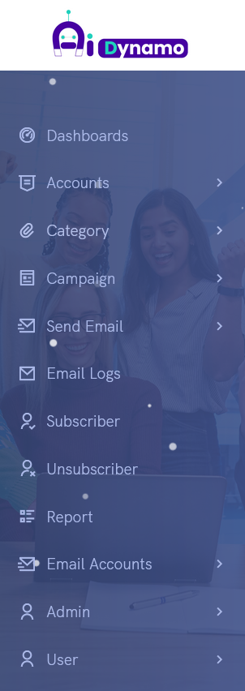

**Widgets to Include:**

* **Campaign Overview**: Total campaigns created, active campaigns, completed campaigns.
* **Email Sent/Read**: Count of emails sent and opened.
* **Downloads**: Number of assets/downloads triggered via email links.
* **Live Users by Country**: Real-time geographic distribution of active users.
* **Sessions by Countries**: Analytics on where users are accessing from over a given period.
* **User Device Analytics**: Desktop, Mobile, Tablet (device-based segmentation).
* **Top Assets**: Display of most downloaded/shared files or campaign assets.

**Functionality:**

* Option to filter data by **day, week, or month**.
* Interactive charts (bar graphs, pie charts) to visualize trends.

**2. Accounts (Client)**

This module manages **Clients or partners** whose campaigns we manage.

**Core Features:**

* **Add, Edit, Active/Inactive Accounts**.

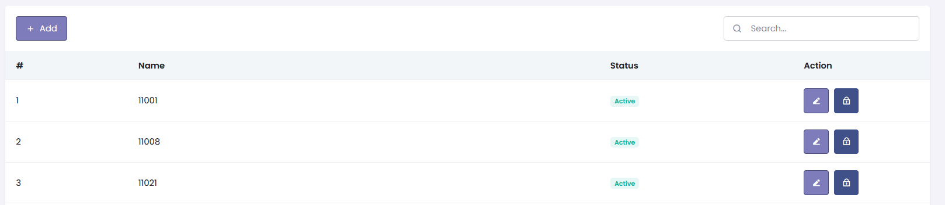

* **Add Accounts**
  + **Name**
  + **Description**
  + **Upload** Default **Web Template File** by Clients or partners.
  + **Upload** Default **Email Template File** by Clients or partners.

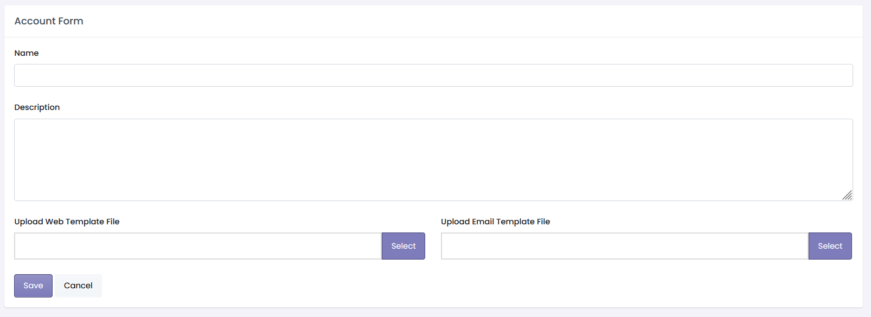

**3. Categories (Industry-Based Campaign Segmentation)**

Organizes campaigns by **industry type** for easier management and reporting.

**Features:**

* Create categories like **BFSI, Manufacturing, Healthcare, Retail, Technology, etc.**
* Assign campaigns under appropriate categories.

**Categories List:**

* Add
* Category Name
* Subcategories
* Active/inactive

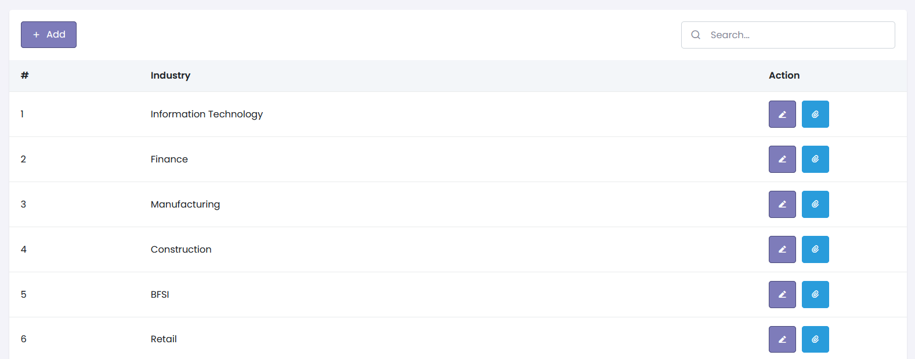

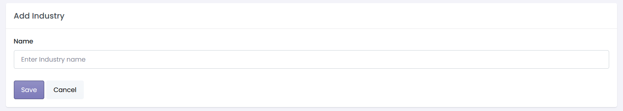

**4. Campaign (Create, Modify, Status Tracking, Active / Inactive)**

Manage campaigns from **creation to tracking their status**.

**Key Actions:**

* **Create Campaign**:
  + Define campaign name, target audience list, and schedule.
  + Design Email template and landing pages according to vendor.
  + Assign the campaign to a **Category** and vendor (if applicable).
* **Modify Campaign**: Update the campaign details mid-way.
* **Set Campaign Status**:
  + Draft / Scheduled / Active / Completed / Paused / Cancelled.

**Add Campaign:**

* **Add**
* Select **Categories**
* **Name**
* **Description**

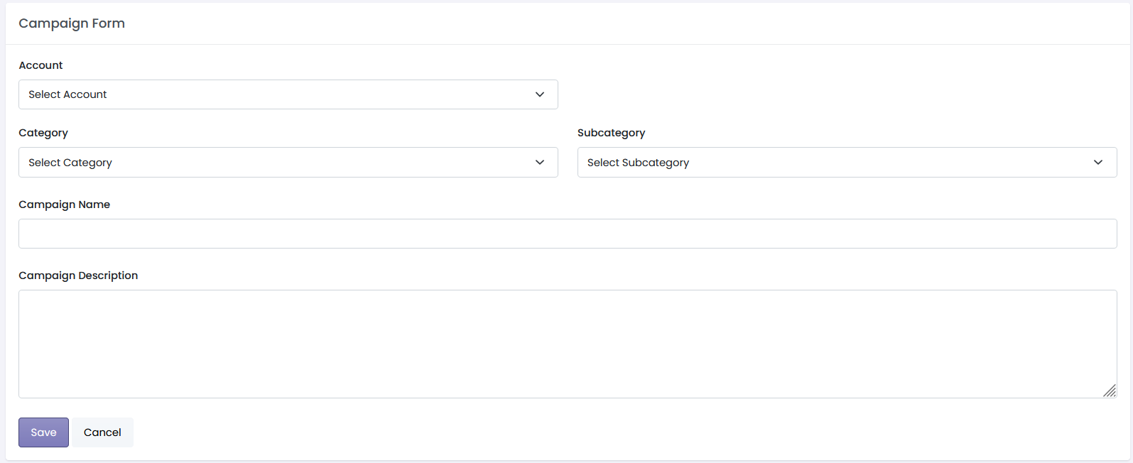

**Campaign List:**

* **Add Campaign**
* **Name**
* **Account**
* **Status**
* **Action (Edit, View Assets, Active/Inactive)**

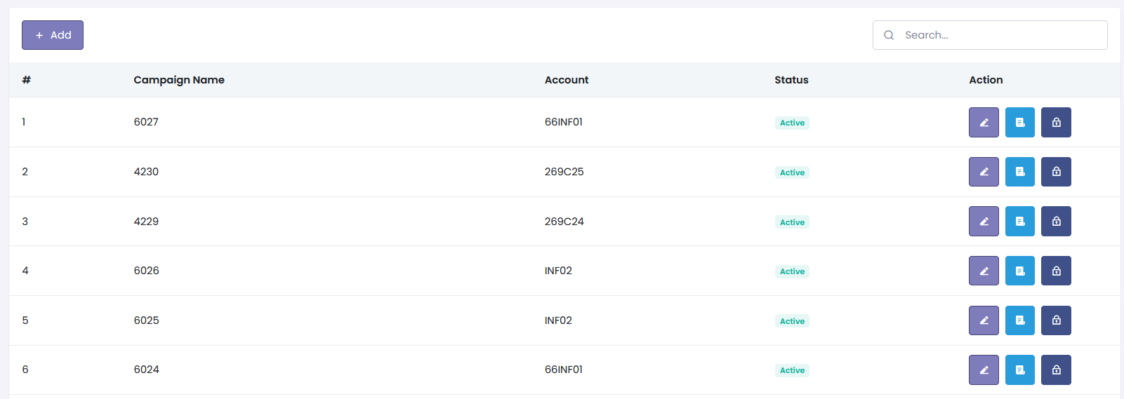

* **View Asset**
* **Add Asset**
* **View Asset**
* **Add Custom Question**
* **Sent Emails**
* **Subscribers**
* **Active/Inactive**

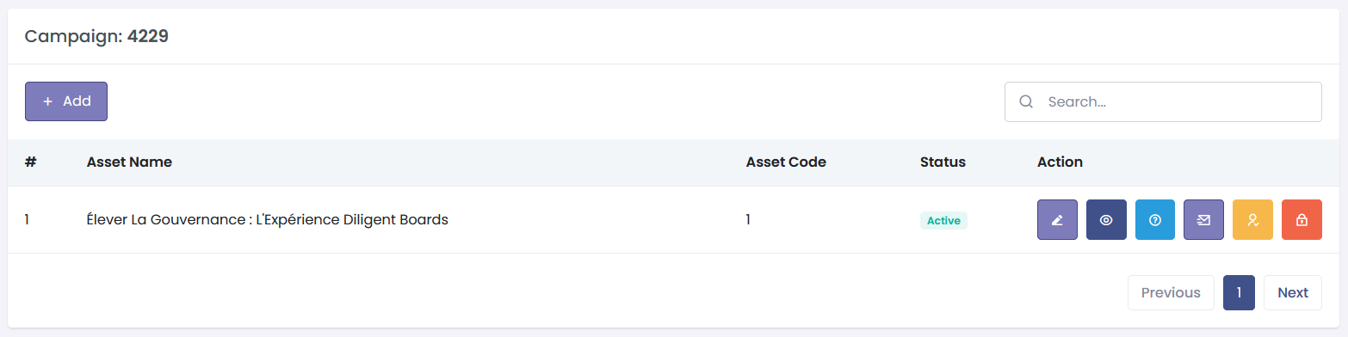

* **Add Asset / Edit Asset**
* **Asset Name**
* **Asset Code**
* **Asset Description**
* **Asset Type (Webinar/Event/PDF)**
* **Link (Webinar/Event)**
* **Mail Subject**
* **Asset Title**
* **Download form title**
* **Download form button text**
* **Download form confirmation text**
* **Upload Logo**
* **Upload Logo 2**
* **Upload Asset Image**
* **Upload PDF**
* **Upload Web Template File**
* **Upload Email Template File**

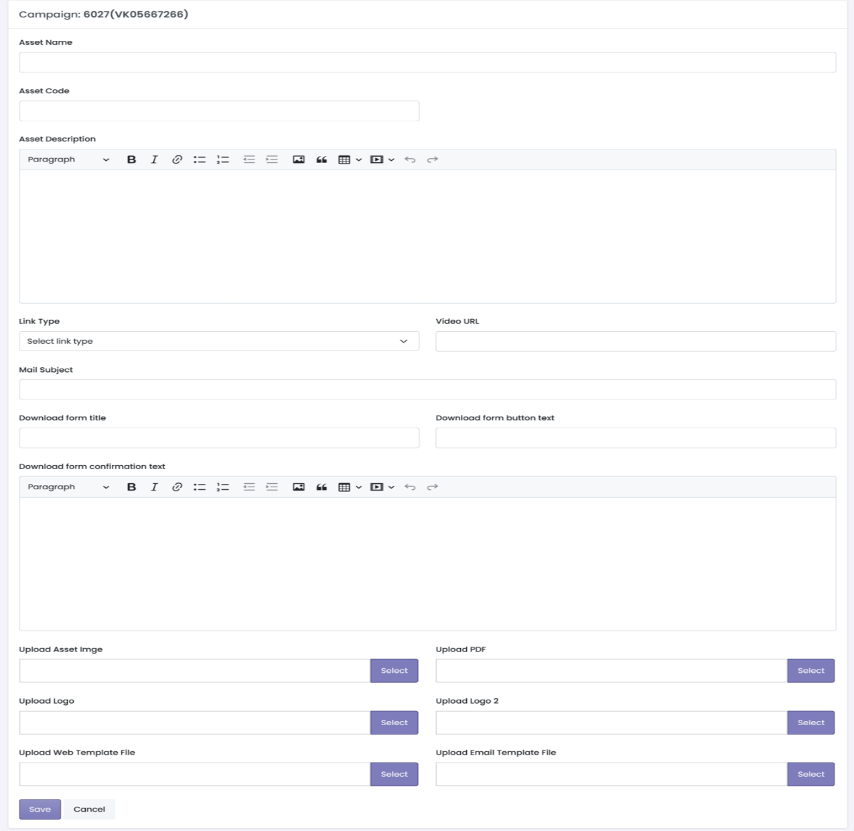

* **View Asset**

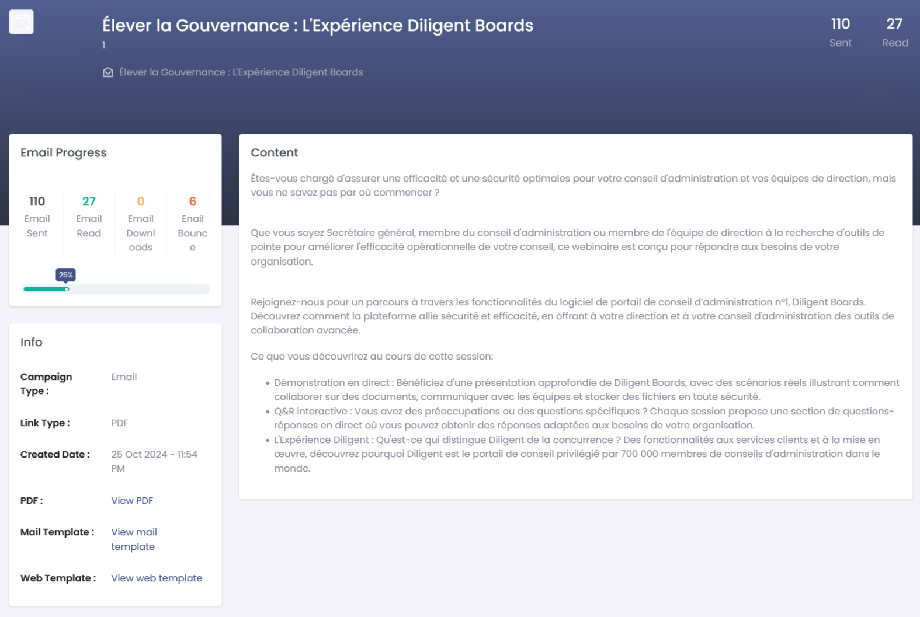

* **Add Custom Question**

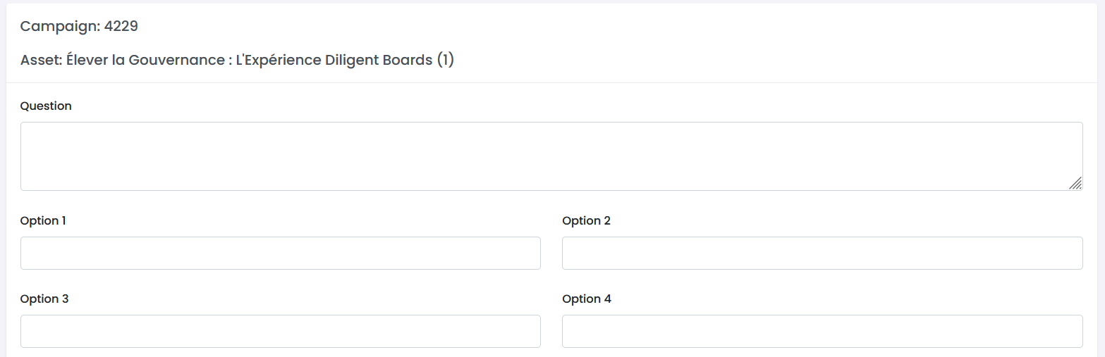

* **Sent Emails**

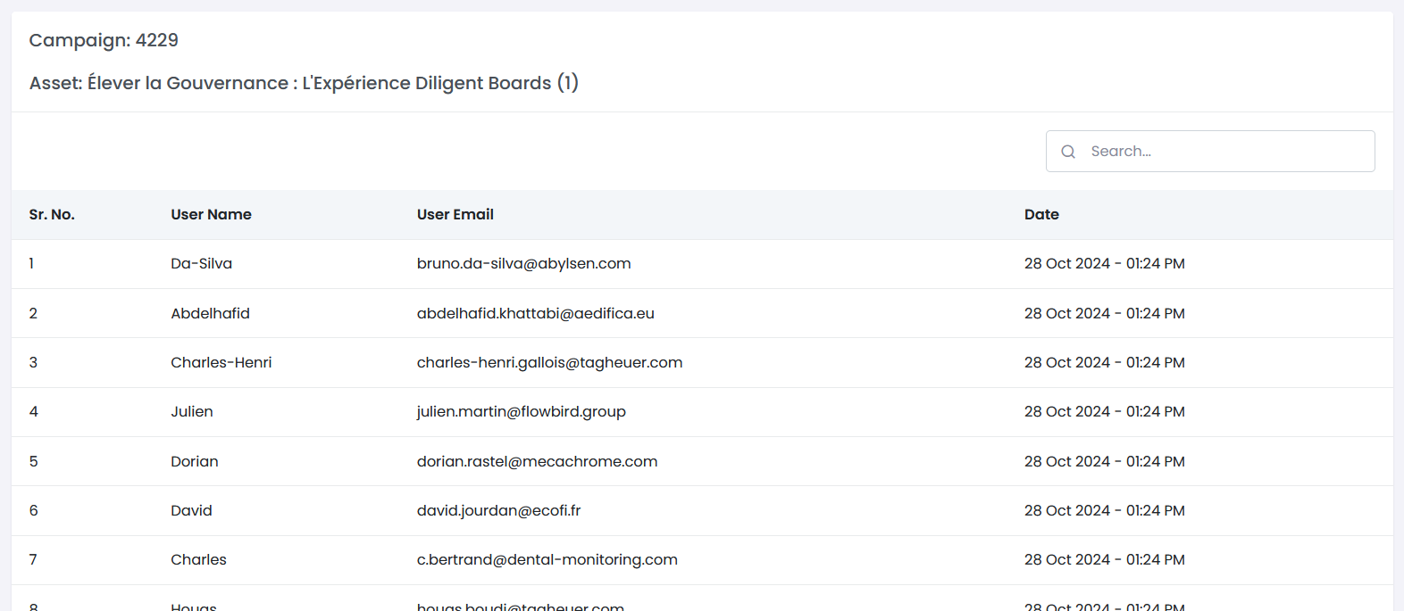

* **Subscribers**

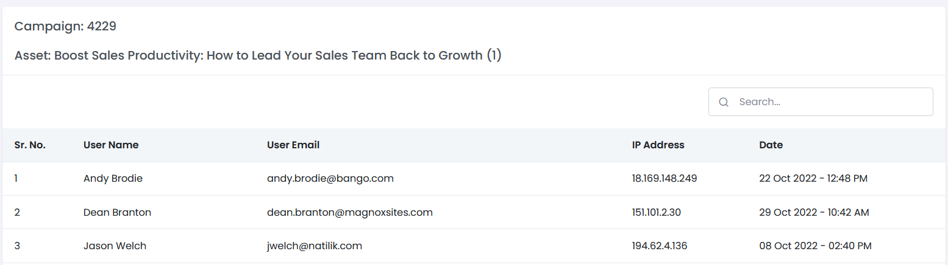

**5. Send Email (Single | Bulk)**

Facilitates **Email Distribution** for campaigns, either individually or in bulk.

**Features:**

* **Single Email**:
  + Send a personalized email to a specific user.
  + Select from predefined templates.

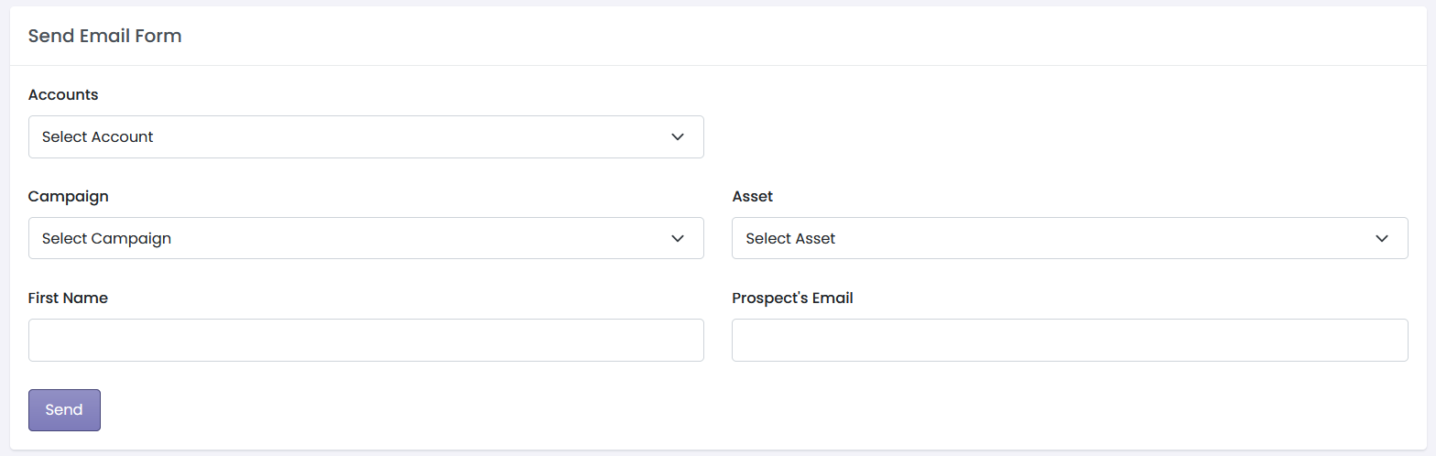

* **Bulk Email**:
  + Upload CSV file or **Segment audience** (by location, category, campaign, etc.).
  + Use dynamic placeholders for **personalization** (e.g., Name, Campaign Name).
  + Schedule bulk emails for **Specific times**.

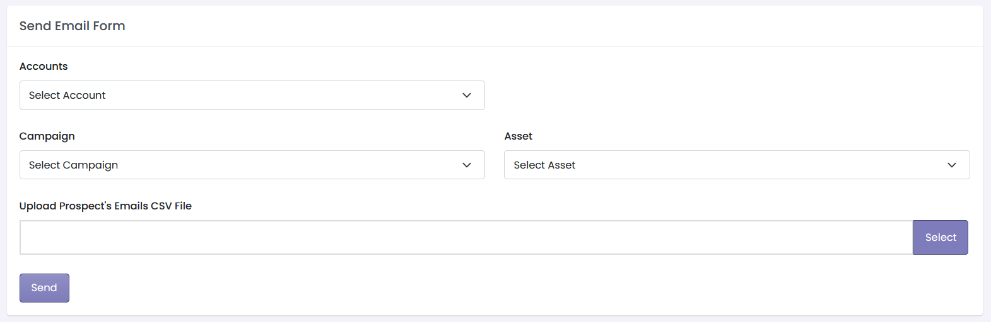

**6. Email Logs (Tracking Reads, Bounces, and IP Address)**

Tracks detailed metrics related to **email interactions**.

**Information Captured:**

* **Downloads**: Which emails or links resulted in asset downloads.
* **Reads/Opens**: Track open rates for each email.
* **Bounce Status**: Identifies emails that failed (soft/hard bounces).
* **IP Address Tracking**: Log IPs from which emails were opened.
* **Device Type**: Captures the device used to open the email.

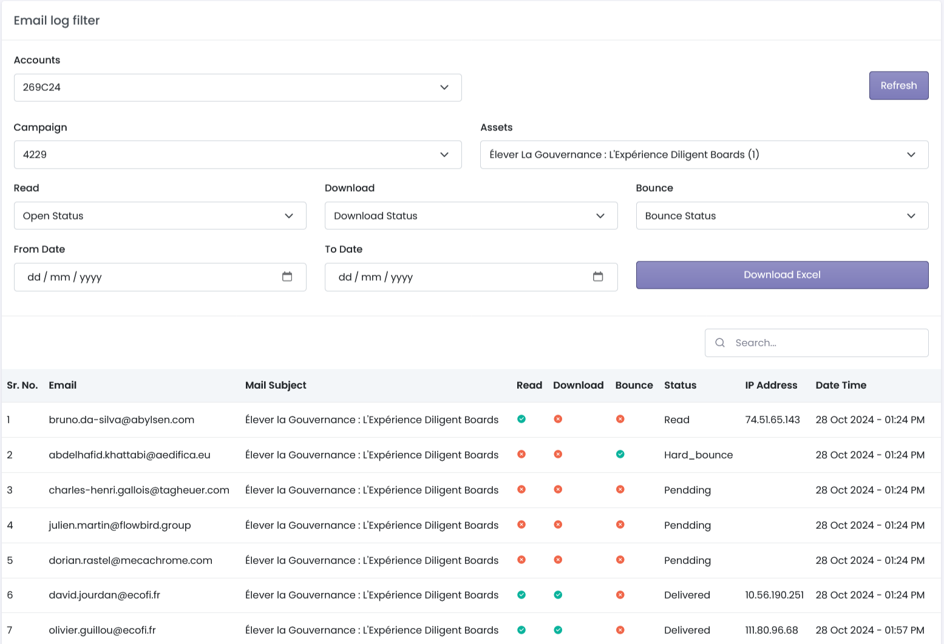

**7. Subscribers (Based on Campaign Subscriptions)**

Manage users who have **subscribed to specific campaigns**.

**Features:**

* View **subscribers list by campaign**.
* **Add, remove, or segment subscribers** based on industry, location, or behaviour.
* 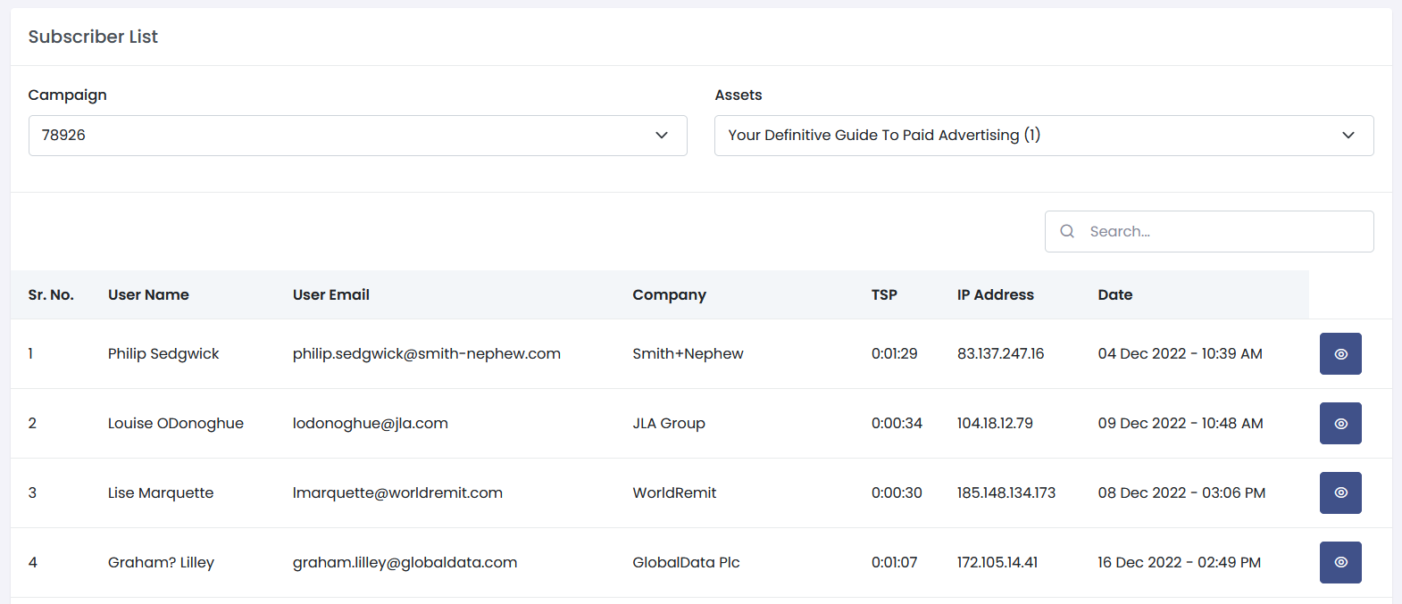Capture subscriber attributes (Name, Email, Country, Phone no. & other required details etc.).

**8. Unsubscribes (Manage Unsubscribed Users)**

Tracks users who have **opted out of campaigns**.

**Features:**

* Filter unsubscribes by **campaign**.
* Generate **lists** of unsubscribed users.
* Manage re-subscription or follow-up options (if opted back in).

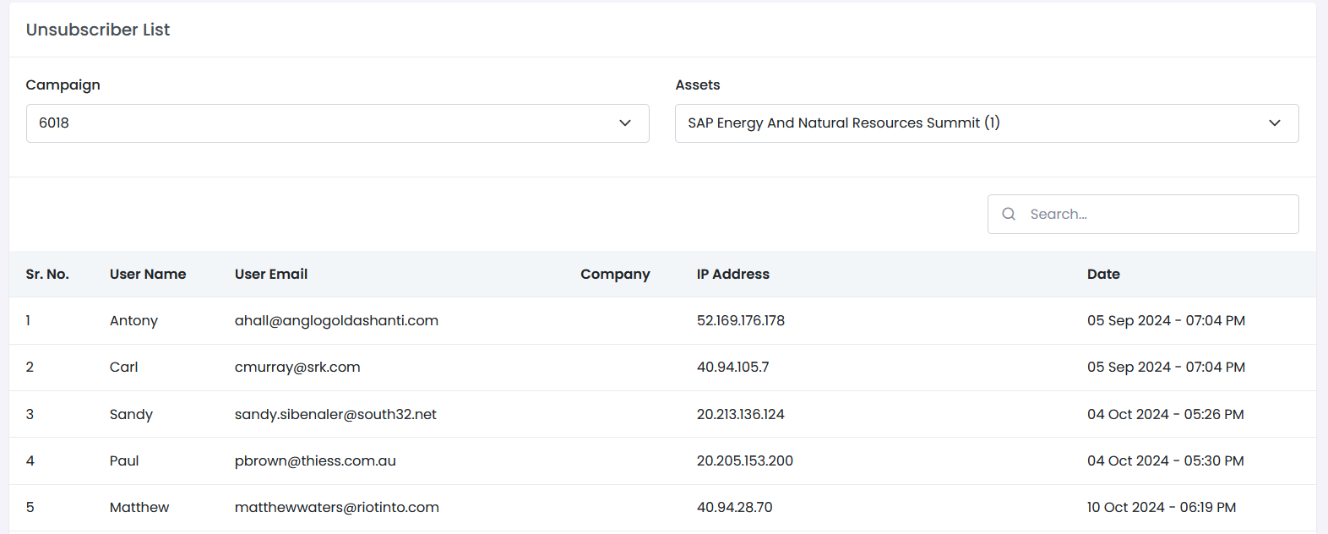

**9. Reports (Campaign Analytics and Detailed Insights)**

This module generates **detailed reports** for campaign performance.

**Reports Include:**

* **Campaign Overview Report**: Summary of key metrics (emails sent, opens, clicks, bounces).
* **Geographical Reports**: Email reads and clicks by location.
* **Device Reports**: Performance by device type (desktop, mobile).
* **Download Reports**: List of downloaded assets per campaign.
* **Bounce Reports**: Emails that failed with details on the type of bounce.

**Export Options:**

* Download reports as **CSV or Excel**.

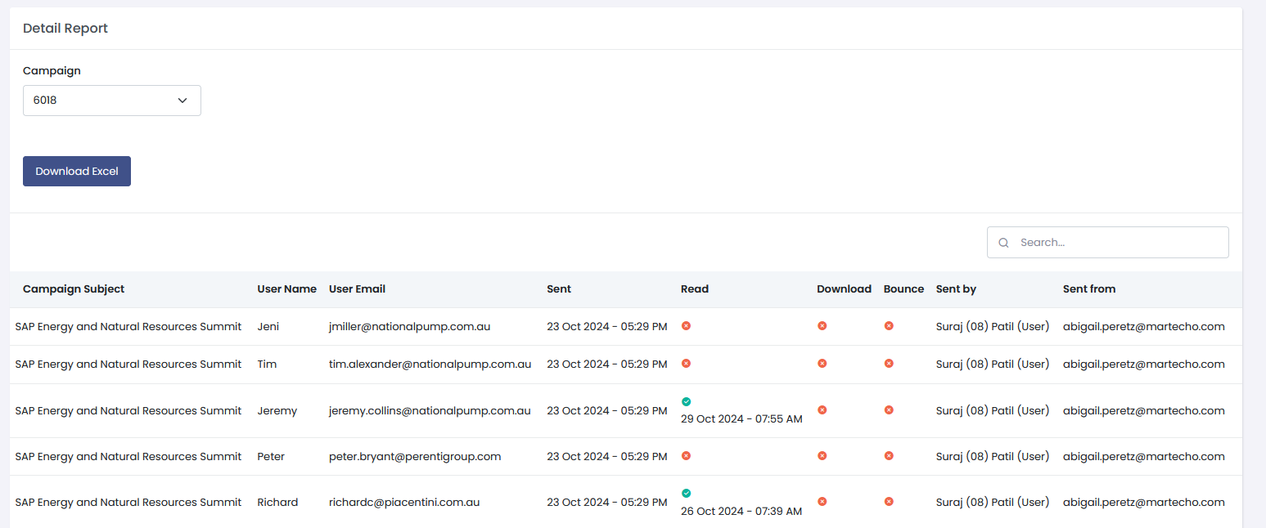

* Assign **roles** or permissions (e.g., Admin, Campaign Manager).
* **Admin**
* **Add, Edit, Active/Inactive**

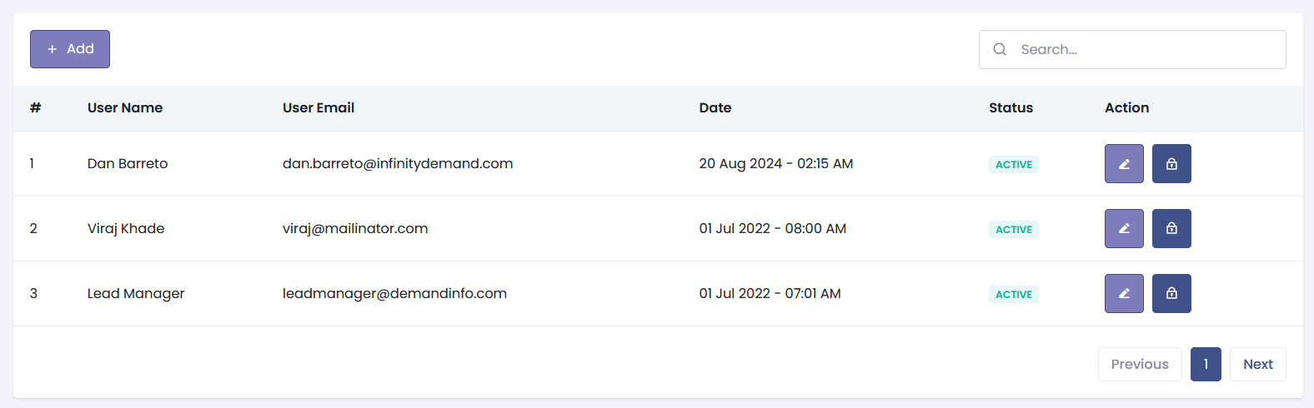

* Frist Name
* Last Name
* Email
* Password

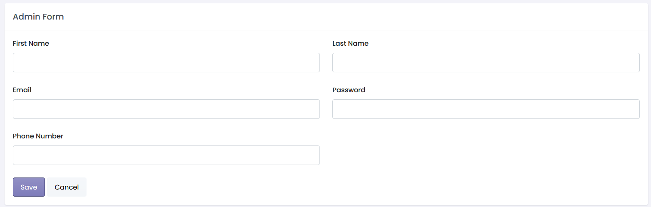

* **Email Account**
* Add, Edit, Active/Inactive

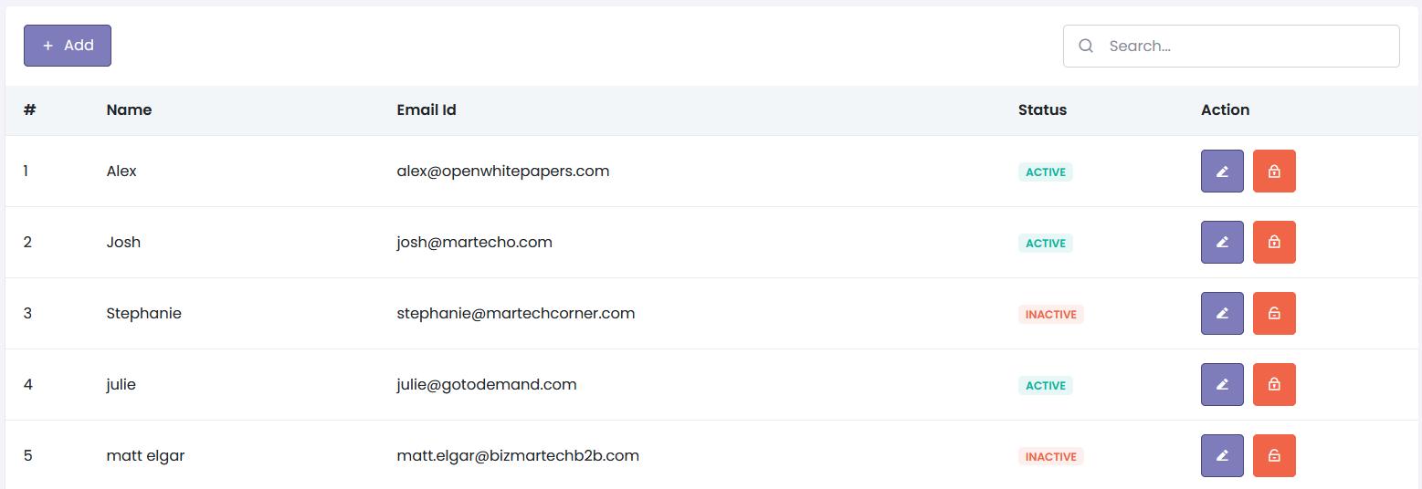

* Name
* Email ID
* Password

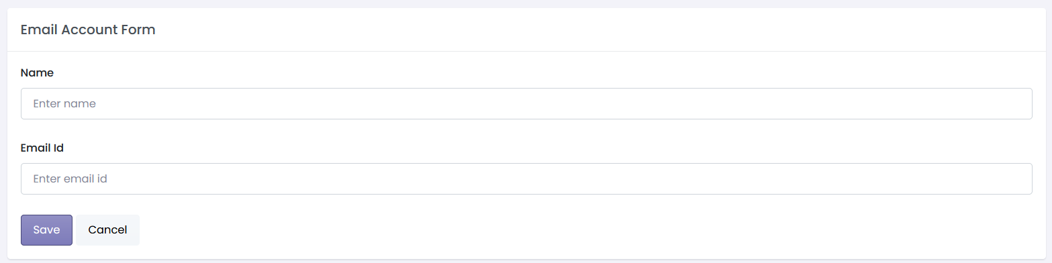

* **User Name**
* Add, Edit, Active/Inactive

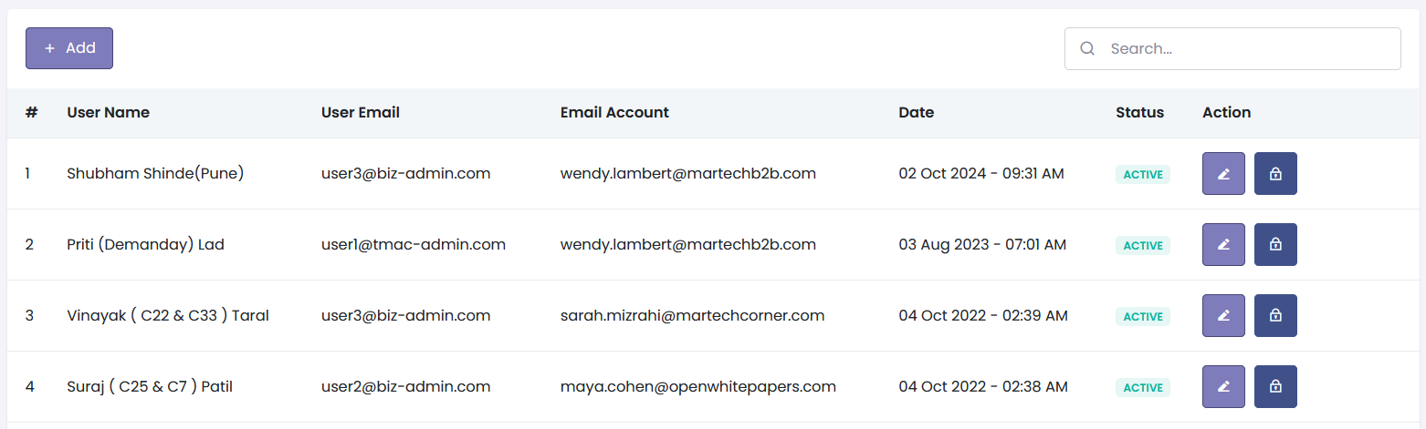

* **Add**
* First Name
* Last Name
* Email
* Password
* Email Account

